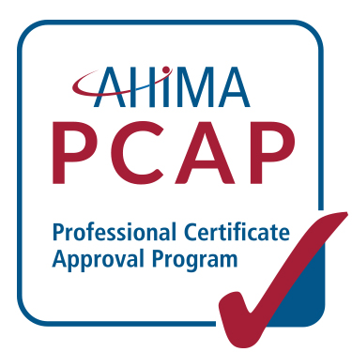

Self-Assessment; based on the 2014 Coding Certificate Competencies

under the AHIMA Professional Certificate Approval Program (PCAP)
This document includes one example of how to assess a single student learning outcome (curricula competency) in each domain covered under the 2014 PCAP Coding Certificate Competencies. Every program should insert additional rows into this document, add the remaining 2014 PCAP Coding Certificate Competencies, and then conduct a full assessment to outline how each student learning outcome is achieved for the entire set of curricula competencies in your medical coding certificate program. When completing this document, each program should have at least one example for every student learning outcome within the relevant domains. The goal of this Self-Assessment is to promote alignment, reduce redundancy across courses and ensure content is being addressed at the appropriate Bloom’s Taxonomy level.

Glossary of Terms
Assessment Methods: How is the program teaching that objective/Student Learning Outcome? How do you ensure the student is learning the concept (what kinds of tasks will reveal the students have achieved the learning outcome)?
Bloom’s Taxonomy: Bloom’s Taxonomy levels are used to measure how well a student is expected to master a concept. Bloom’s Taxonomy is a classification system that divides the way people learn into three domains: 1. cognitive (intellectual outcomes, mental skills), 2. affective (growth in feelings or emotional areas), and 3. psychomotor (manual or physical skills). Bloom’s cognitive domain serves as the measurement scale for the student learning outcomes included in the curricula.
Domain: A broad category with divisions (sub-domains) of related content. The Domains and subdomains specify the HIM body of knowledge and practice.
Objective: What is the student going to learn? This must be written in measurable terms, quantitatively or qualitatively (rubric, number of correct, etc.).
Student Learning Outcome: A behavior; what the learner will be able to do; a condition - how will the learner be able to do it. It should be measurable at a minimally acceptable standard and demonstrate how well the learner is able to do the task. Measurement of success is through assessment of achievement of the stated student learning outcome. Additional resources on aligning student learning outcomes and objectives can be found at: http://www.cmu.edu/teaching/assessment/howto/basics/objectives.html

Program Self-Assessment
2014 Domains | Student Learning Outcome example (the desired Bloom’s Taxonomy Level is listed in parentheses following the student learning outcome) | Objectives: | Assessment Methods (Are they Measurable)? | Are Objectives in Syllabus/Course Numbers? | Notes
I. Data Content, Structure & Standards (Information Governance) | I.A 2 Evaluate the accuracy of diagnostic and procedural coding (5) | Student will be able to audit assigned ICD and/or CPT codes and determine if coding is accurate and how it will positively or negatively impact data reporting. | - Student is given clinical information for which an incorrect set of codes have been assigned. Student will recommend corrections to the assigned codes at an 85% accuracy level.  - Require completion of quiz or submission of narrative assignment which illustrates why codes are incorrect, the correct codes, and the impact of reporting incorrect/invalid code set(s) with an accuracy of at least 85%.
II. Information Protection: Access, Disclosure, Archival, Privacy & Security | II.A.1 Apply healthcare legal terminology (3) | Student will be able to write a procedure for disclosure of Health Information for a court subpoena | - Using the legal terminology of the subpoena scenario, create a procedure for disclosure of a health record to be used in a court proceeding (with 90% accuracy).  - Review the process of another institution to determine accuracy.

IV. Revenue Management | IV.A.1 Apply policies and procedures for the use of data required in healthcare reimbursement (3) | Student will be able to identify the payment methodologies used by various healthcare systems. | - Given a set of payment methodologies and a set of healthcare systems identify which payment methodology is used for each healthcare system with 95% accuracy  - Create a table of payment systems and the rate method used for each (with 90% accuracy).
V. Compliance | V.A.1 – Apply policies and procedures to ensure organizational compliance with regulations and standards (3) | Student will verify if a regulation standard is included in a policy and procedure | - Students will indicate what is missing from a policy and procedure of an HIM dept. with 85% accuracy, in relation to a standard of The Joint Commission  - Test question: Essay- Explain what could happen if an organization does not have a compliance plan in place?

